**Creating a New Data Sharing Account on the**

**MaineEARNS Data Submission Site**

1. **Go to home page** [**https://www1.maine.gov/cgi-bin/online/cwri/start**](https://www1.maine.gov/cgi-bin/online/cwri/start)  **and click “No account? Sign Up”**

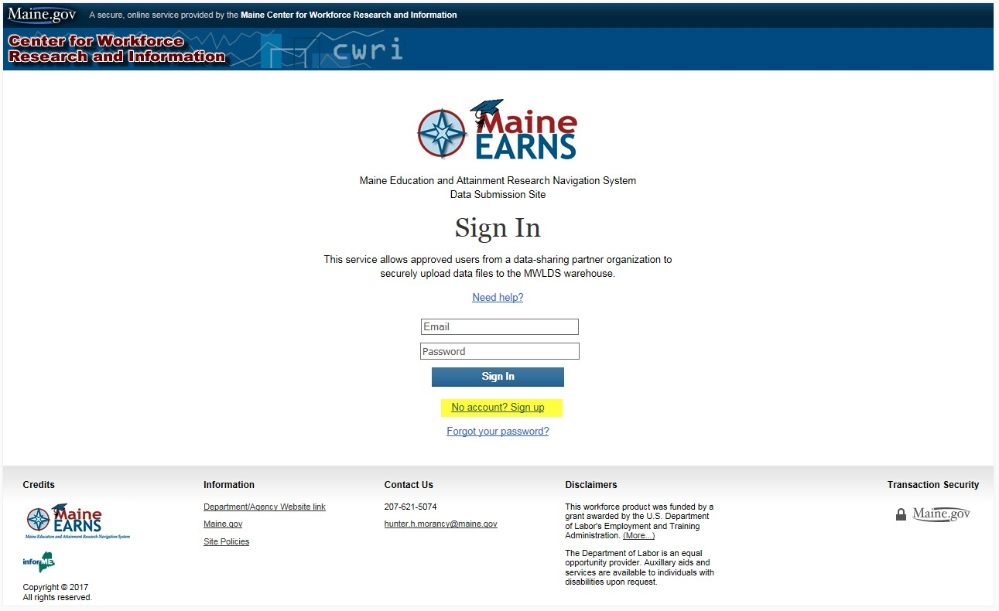

1. **If your organization does not currently have an account of the**

**MaineEARNS data submission portal, click “no.”**

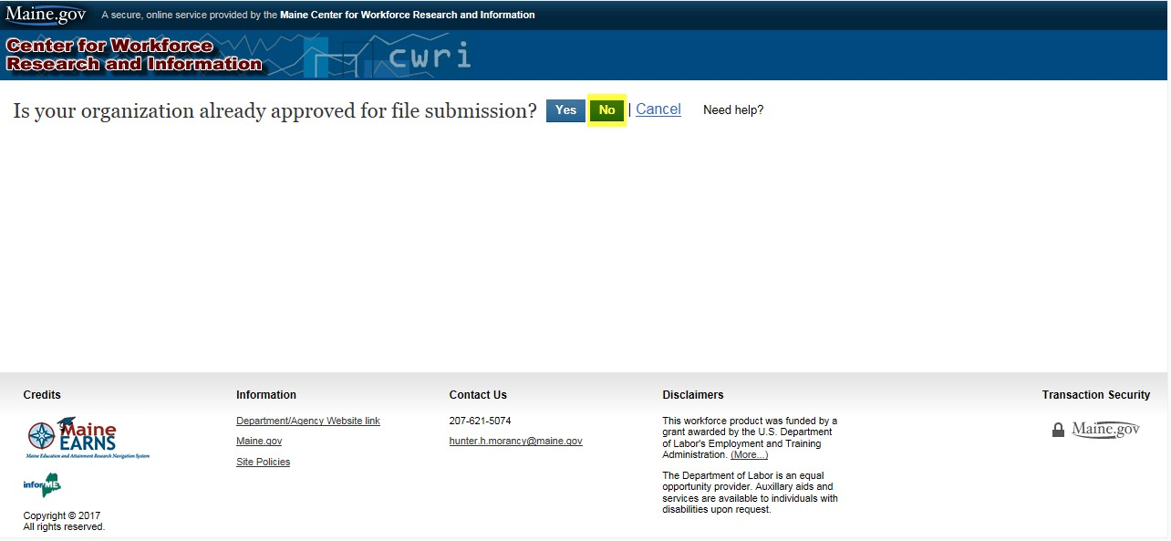

1. **A dropdown will appear on the page. Enter corresponding information to create your account.**

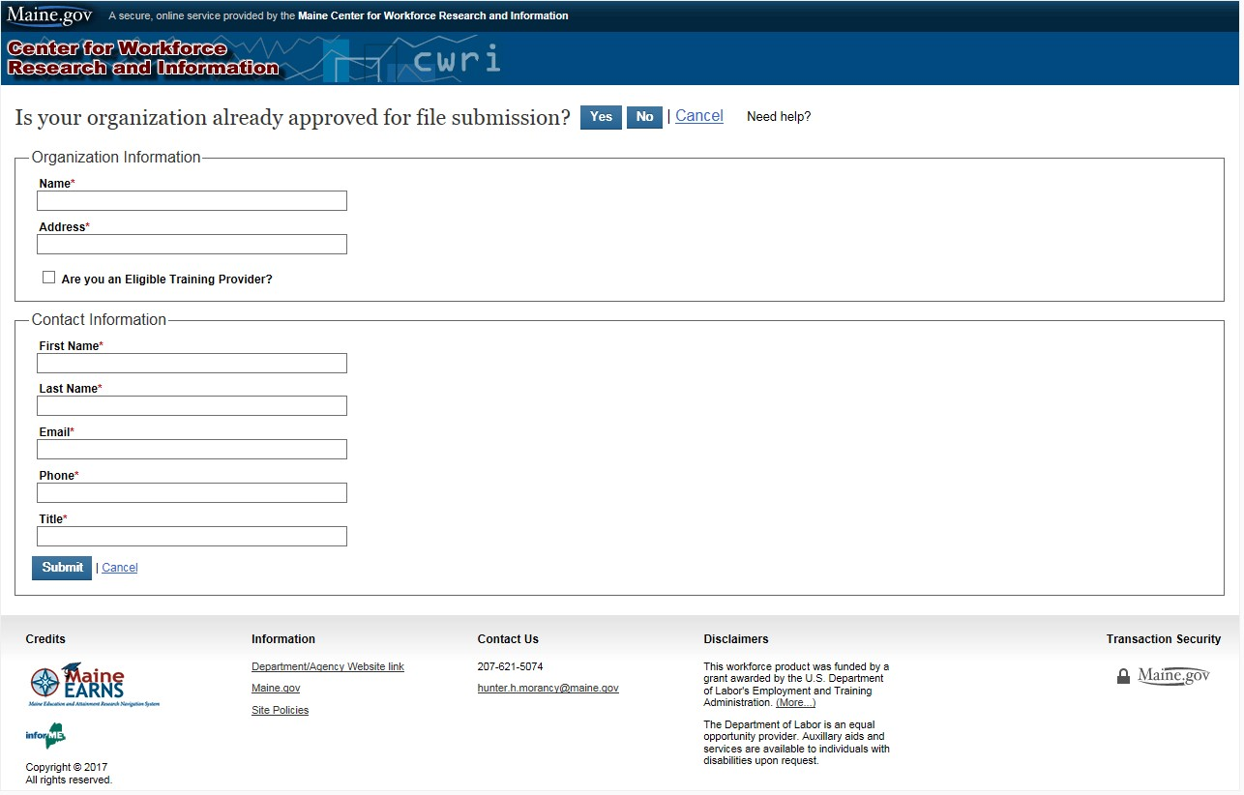

1. **Once you click submit, you will receive the following email from info@informe.org:**

“Your Organization request to use the MaineEARNS Data Submission Site has been received. Once reviewed, you will receive a confirmation email and a link to create a password, activating your account. Response time will vary and may take several days.”

NOTE: You must wait to be approved by a State Administrator before you can proceed. When your organization is approved, you will receive an email from info@informe.org stating:

“Your MaineEARNS Data Submission Site user account has been approved. Please click the link below to select a password:  [https://www3.maine.gov/cgibin/online/cwri/resetpwd?uid=236&n=63c6aa25a3479289e22f4ad715f297269b5 729fb](https://www3.maine.gov/cgi-bin/online/cwri/resetpwd?uid=236&n=63c6aa25a3479289e22f4ad715f297269b5729fb)

This link may only be used once and will expire in three days.”

1. **Click on the link to create a new password.**

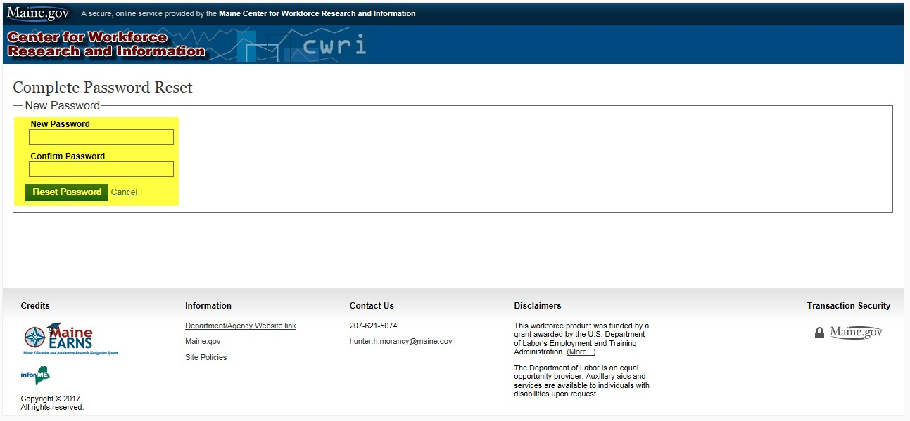

Passwords must be at least 8 characters and must include at least one number, one uppercase letter one and lowercase letter.

1. **When you click “reset password” your password will be generated.**

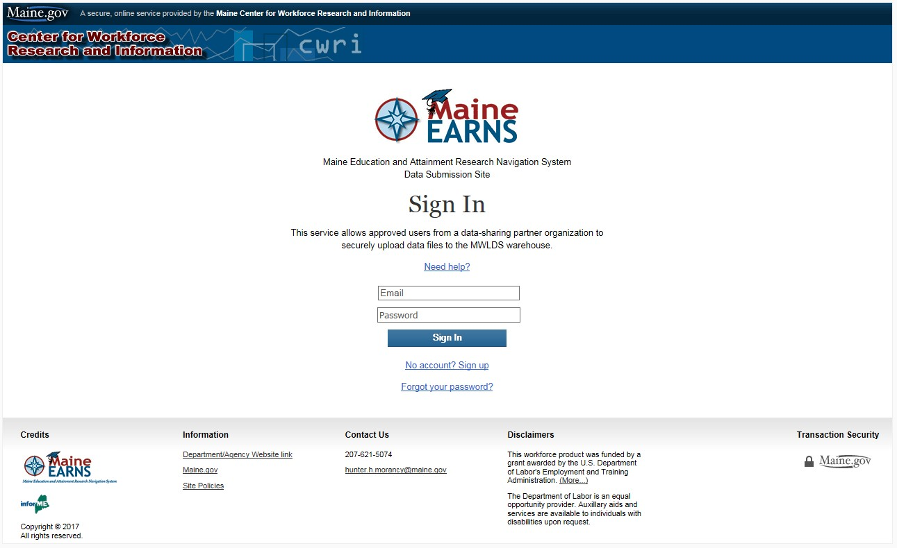

1. **Now you may sign into the MaineEARNs Data submission site using your email and the password you just created. If you have any further questions about signing up, please refer to the user guide or call the number at the bottom of the site.**